MILITARY HISTORY FROM MULTIPLE PERSPECTIVES:
ECONOMY, MEDICINE, INTERNATIONAL LAW AND OTHERS

Part II

Examples of Teaching Plans

Brief introduction of teaching plan:
“Topic 9: International conflicts and crises in the 20th century (I) – the two world wars” in the revised curriculum allows students to explore the origin and impact of the two world wars. In the 20th century, the two world wars and the Cold War had great impact on the shaping of the present world. This topic leads students to explore the fundamental causes of the outbreak of the two world wars, and how the two world wars changed the world order such as the decolonisation in Asia and Africa, and the rise of the ‘Third World’. Students can also learn through case study to understand how the two world wars brought changes in modes of war and improvement in armaments, and how military innovations were used in our daily lives in post-war years; and/or to know that genocide was a repeated historical phenomenon in the 20th century, taking The Holocaust during the Second World War as an example for students to understand the background and the miserable experiences of the Jews during the war and the reflections made by the Germans after the war.

This teaching plan demonstrates how the teacher uses enquiry learning, e-Learning, and collaborative learning to help students understand the improvement in armaments and the change in modes of war in the two world wars and how these changes threatened world peace; and more importantly, to understand the severe damages caused by wars and the harms suffered by the people. In class, the teacher arranges students to discuss and integrate the armaments used in the two world wars and their impact, and the change in the modes of war and their impact. The groups then report to the class the results of their research so that the students can learn through their collaboration. Finally, this teaching plan also follows closely to the curriculum, focusing on guiding students to think about the positive and negative effects of ‘wars and inventions’.

Through this teaching plan, teachers can help students understand the severe damages caused by the wars and the harms suffered by people of various countries. With the improvement in weapons and armaments, as well as the changes in the modes of war, wars have become more deadly. All people in the countries at war, including civilians, will be drawn into the vortex of war and the extent of its
impact has been unprecedented. Teachers can use this to help students understand that peace is hard-won, and students should do their best to prevent history from repeating itself by promoting peace.

To know more (1): Learning history through maps

Teaching plan 1: Wars and Inventions

Europe in 1914

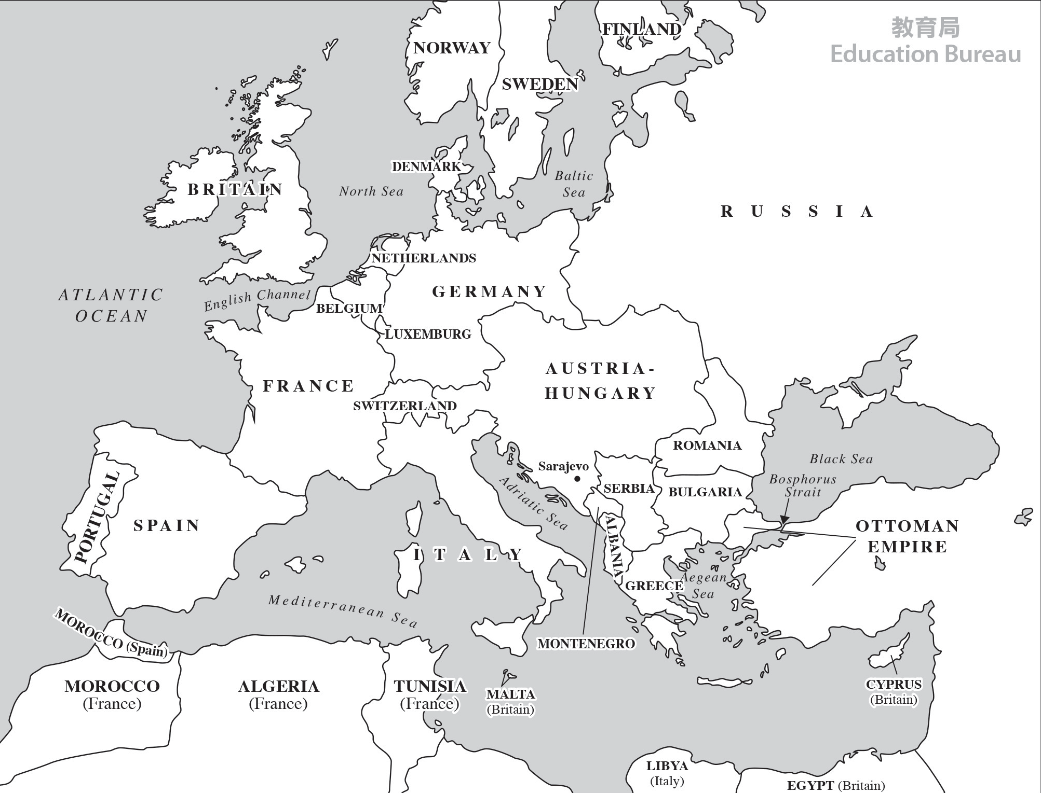

92 Teaching plan 1: Wars and Inventions Teaching plan 1: Wars and Inventions 93

Europe in 1942

To know more (2): English-Chinese Glossary of terms
Trial teaching plan

Wars and Inventions
Target students | S3
Topic of trial teaching | Topic 9: International conflicts and crises in the 20th century (I) – the two world wars (the Extended part)
 | Case study: Wars and inventions
Suggested number of lessons | 1
Suggested lesson time | 60 minutes
Enquiry question | How did the changes in armaments and the modes of war in the two world wars threaten world peace?
Learning objectives
Knowledge | - Know the changes in armaments in the two world wars  - Know the changes in modes of war in the two world wars  - Understand the severe damages caused by the wars and the harms suffered by the people
Skills | - Make use of collaborative skills, critical thinking skills and self- learning skills  - Make deductions and inferences from historical sources  - Analyse how historical events connects with daily lives
Attitude | - Cultivate students’ empathy for the injured and the pursuit of world peace and social harmony from the serious dam- ages caused by the wars and the harms suffered by people of various countries  - Learn from history to prevent history from repeating itself
Learning and teaching strategy
- Enquiry learning
- Collaborative learning
Learning and teaching materials
Pre-lesson task | - Worksheet for pre-lesson task (Appendix 1)
Classwork | - Worksheet for Group discussion 1 (Appendix 2)  - Worksheet for Group discussion 2 (Appendix 3)
Post-lesson task | - RAFT worksheet for extended activity (Appendix 4)

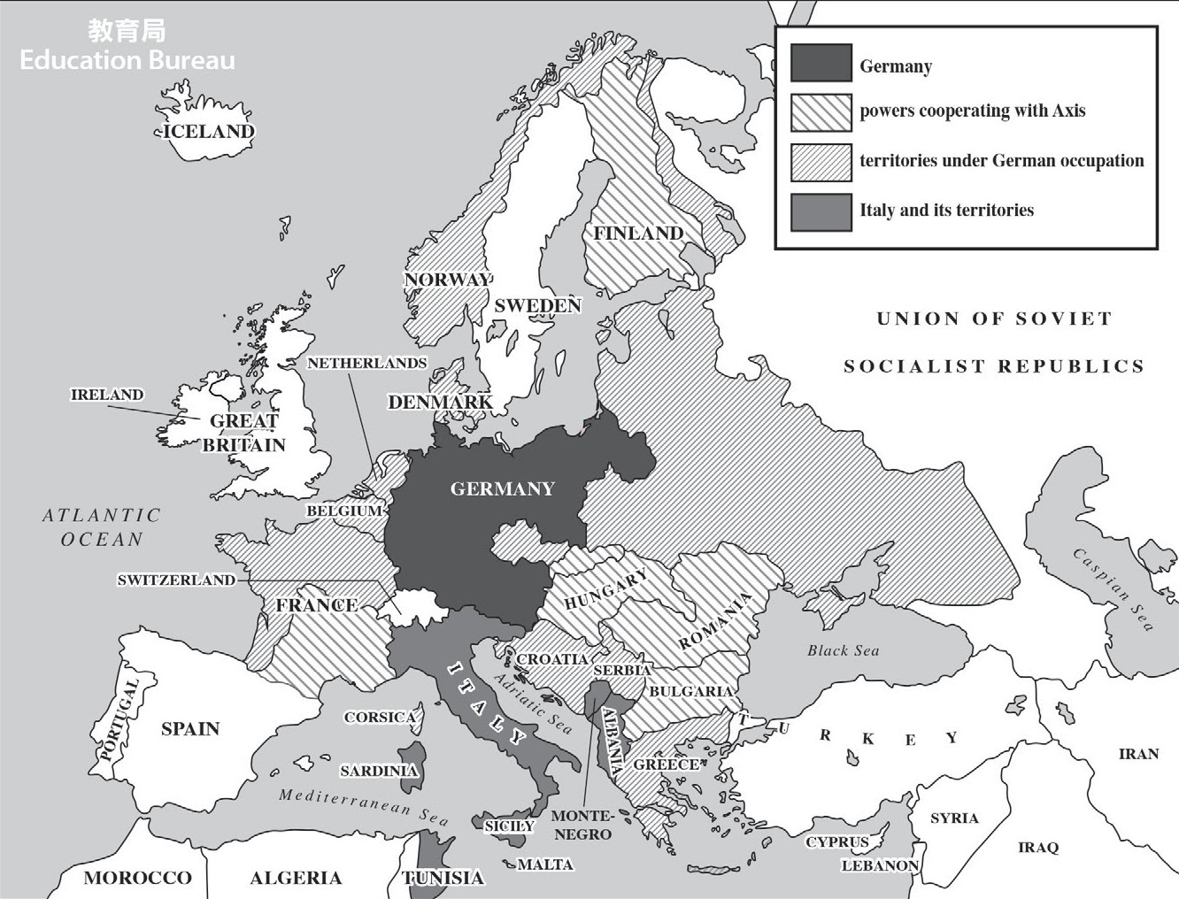
M1903 Springfield | 春田步槍 M1903
Browning machine gun | 白朗寧重機槍
The Battle of the Somme | 索姆河戰役
Tank | 坦克車
The Blitz | 倫敦大轟炸
Zeppelin | 齊柏林飛船
Bomber | 轟炸機
Atomic bomb | 原子彈
Hiroshima | 廣島
Nagasaki | 長崎

94 Teaching plan 1: Wars and Inventions Teaching plan 1: Wars and Inventions 95

Wars and Inventions
96 Teaching plan 1: Wars and Inventions
Teaching plan 1: Wars and Inventions 97
Time | Teaching steps | Learning and teaching activities | Learn- ing and teaching materials
10  minutes | Introduction/ Pre-lesson task follow up | - Teacher introduces learning objectives of the lesson and follows up pre-lesson task.  - Teacher examines students’ understanding of the equipment of the British soldiers and the German soldiers in the First World War as well as important battles, incidents and characters of the two world wars. | Appendix 1
- In groups of 4, students watch the video about “The Trench” and then discuss the following questions:
  - What are the characteristics of the trench terrain? What advantage does this kind of terrain bring to warfare?
  - How did the invention of machine guns lead to the emergence of trench warfare?
20  minutes |  | - Students study historical sources and watch the video about “The Tank” and then discuss the following questions: | Appendix 2
 |  | 1. What are the advantages of the tanks on the battlefields?
 | Collaborative learning | 2. How does the invention of the tanks change the mode of war?  - Group members complete Worksheet for Group Discussion 1.
25  minutes |  | - Each group studies the information about “The Blitz” and the different “bombers” of the two world wars, and then discusses the following questions:  - What damage does the invention of bombers bring?  - What are the differences between the Zeppelin and the He 111 H bomber?  - Group members complete Part I of Worksheet for Group Discussion 2. | Appendix 3
 |  | - Each group studies the sources and watch the video about “Atomic bombs” and then discuss the following question: How powerful is the destructive power of atomic bombs?

Time | Teaching steps | Learning and teaching activities | Learn- ing and teaching materials
- Group members complete Part II of Worksheet for Group Discussion 2.
- Each group integrates the changes in armaments and modes of war in the two world wars and completes Part III of Worksheet for Group Discussion 2.
5  minutes | Summary/ Post-lesson task follow up | - Teacher guides students to think about how the changes in armaments and modes of war in the two world wars threatened world peace.  - From the serious damage caused by the war and the harms suffered by people of various countries, teacher reminds students to have empathy for the injured and the pursuit of world peace and social harmony.  - Students complete RAFT worksheet for extended activity at home. | Appendix 4

Trial teaching flow

How did the changes in armaments and the modes of war in the two world wars threaten world peace?
Appendix 1
Pre-lesson task

Worksheet for pre-lesson task:
  - Data-based questions

    - Study Source A and answer the question that follows.
Source A: The following two photos show the equipment of German and British soldiers respectively in the First World War.

Equipment of a German soldier Equipment of British soldiers

Source: British Library, Photo 24(348)

Source: Library of Congress, Prints & Photographs Division, LC-DIG-ggbain- 18202
    - Watch the video (Source B) and answer the question that follows.
Source B: The following video shows the firepower of one of the rifles SMLE Mk III used by British soldiers in the First World War.
Video title: SMLE MkIII*
Video URL: https://www.youtube.com/watch?v=0dvrUOyXNX0

With reference to Source B, was SMLE Mk III rifle convenient for continuous firing? Explain your answer.
No. The rifle was only able to be fired in a single shot, while the magazine could only store a limited number of bullets, resulting in the need for frequent loading.

    - Watch the video (Source C) and answer the question that follows.
Source C: The following video shows the firepower of a machine gun “MG08” used by German soldiers in the First World War.
Video title: MG08 Machine Gun
Video URL: https://www.youtube.com/watch?v=xX2I8xkDSMk

With reference to Sources B and C, which—SMLE Mk III rifle or the MG08 machine gun—would be more destructive? Explain your answer.

“MG08” machine gun would be more destructive. Compared with “SMLE Mk III” rifle, the machine gun could fire more bullets at the same time, resulting in greater destruction.

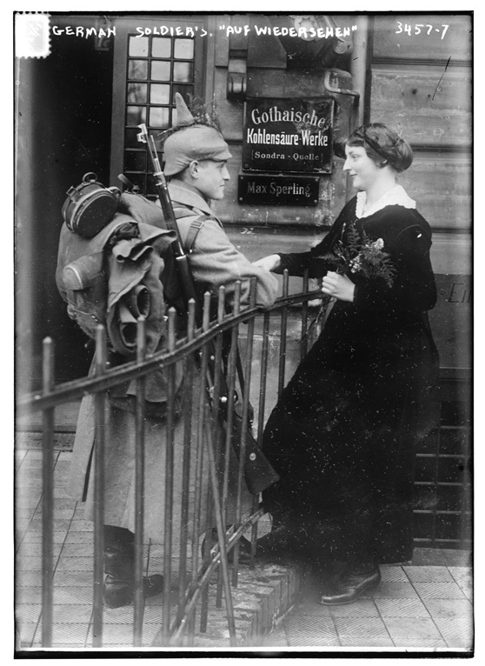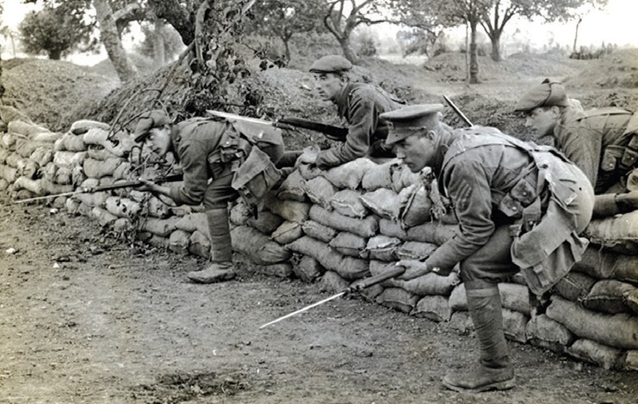
Were German and British soldiers equipped with similar weapons? Explain your answer with reference to Source A.

Yes. Both German and British soldiers were equipped with a rifle, with a bayonet on it.

98 Teaching plan 1: Wars and Inventions Teaching plan 1: Wars and Inventions 99

    - Study Source D and answer the question that follows.
Source D: The following information describes the Battle of The Somme in World War I.

Pre-assessment task:

Complete the following table with information related to the two world wars.

The [British] offensive began at 07.30am on 1 July 1916. Since the artillery bombardment had failed to cut the German barbed wire or damage the defenders’ dugouts in most places, the inexperienced soldiers were ordered to advance in long, close-formed lines. German machine-gunners emerged from their intact shelters and mowed down the oncoming British infantry. The cost 57,470 British casualties – of which 19,240 were killed – making the first day of the Somme the bloodiest in British military history.
Important battles / incidents /
characters of the two world wars
Characteristics / features of
military inventions of the two
world wars
Source: https://www.iwm.org.uk/history/what-happened-during-the-battle-of-the-somme
(Example of answers)
Huge damage Mechanised infantry
Attach importance to pace and the
thickness of amour
(Example of answers)
Paul von Hindenburg Winston Churchill Battle of The Somme D-Day

What impact did the invention of machine gun have on warfare? Explain your answer with reference to Source D.
Source D: The first day of the Battle of The Somme resulted in over 57,000 British casualties. Explanation: The invention of machine gun brought about greater war casualties.
wars
Two world
List the armaments
(or weapons) that were invented or used in World War I
List the armaments
(or weapons) that were invented or used in World War II
(Example of answers)
“SMLE Mk III” rifle “MG08” machine gun Mark 1 tank
Zeppelin
(Example of answers)
Tiger 1, the German tank
Dive bomber Aircraft carrier Atomic bomb

100 Teaching plan 1: Wars and Inventions Teaching plan 1: Wars and Inventions 101

How did the changes in armaments and the modes of war in the two world wars threaten world peace?

Worksheet for Group discussion 1:
In groups of 4, students watch videos and study sources. Members then discuss and answer related questions.

Mode of war: The emergence of trench warfare
Watch the following video and answer all questions that follow. Video title: Conditions in Trenches-Dan Snow’s Battle of the Somme Video URL: https://www.youtube.com/watch?v=FvYIIuxh2kY
      - With reference to the video, suggest one characteristic of the trench terrain and
one advantage that this terrain would bring to warfare.
Terrain: low to the ground, narrow and curved Advantage: Effectively avoid enemy artillery attacks

      - With reference to the pre-lesson task and the video, how did the invention of machine guns lead to the emergence of trench warfare?
Due to the powerful firepower of machine guns, in order to avoid being attacked, soldiers dug trenches to avoid stray bullets, and trench warfare thus emerged.

New armament: The emergence of tanks
Study Sources A, B and C, and answer the question that follows.
Source A: The following introduces the information of British tanks during World War I.
Name | Mark I Male Tank | 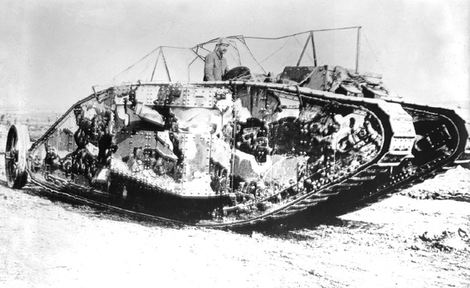
Weight | 28.4 tons
Max speed | 5.95 km/h
Trench crossing capability | 3.5 m
Weapons assembled | 2 x 57mm guns  4 x 7.62 mm machine guns
 |  | Source: © IWM Q 2488
Amour thickness | 6-10mm (safe from light arms attack)
Source: Fletcher David. British Mark I Tank 1916. (Oxford: Osprey Publishing, 2004).

War I.

Source: © IWM Art.IWM PST 13305
Appendix 2
Classwork 1
Source B: The following is a propaganda poster related to a British tank in World

Source C: The following video shows the tank in action during the First World War.
Video title: Mark I tank moves over a trench as soldiers sit on it during the Battle of Arras
Video URL: https://www.youtube.com/watch?v=FvYIIuxh2kY
      - With reference to Sources A, B and C, identify the advantages of the tanks on the battlefields.
        - Thick amour: The thickness of amour is about 6-10mm, which can prevent soldiers from light firearm attack (Source A), thus making it a “travelling fortress” (Source B).
        - Strong firepower: The tank is equipped with two 57mm guns and 4 machine guns. (Source A)
        - Capability of crossing trench and obstacles: The tank can “cuts through the wire under fire” (Source B) and it can also cross trenches. (Source C)

      - How did the invention of the tanks change the mode of war?
Since trenches were no longer effective in face of tanks, trench tactics then declined.

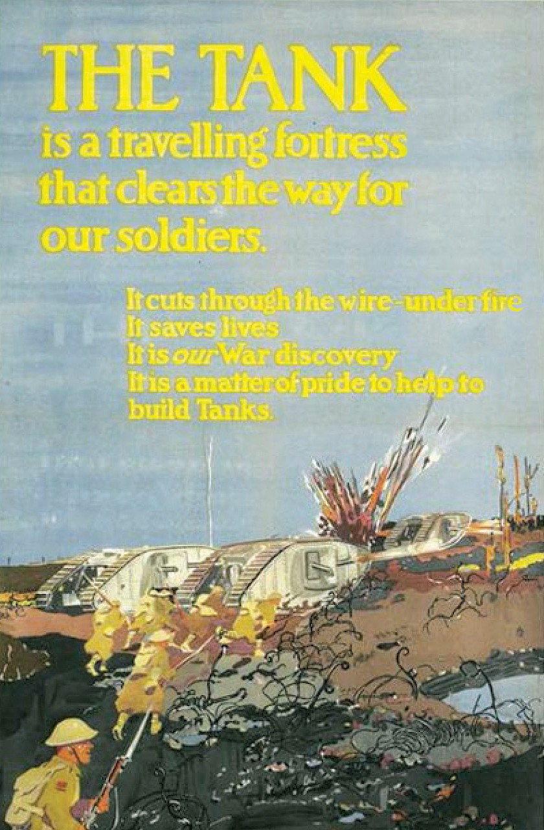 102 Teaching plan 1: Wars and Inventions
Teaching plan 1: Wars and Inventions
103

How did the changes in armaments and the modes of war in the two world wars threaten world peace?

Worksheet for Group discussion 2:
In groups of 4, students watch videos and study sources. Members then discuss and answer related questions.

Development of air warfare: The emergence of bombers
  - Study Sources A and B below, and answer the question that follows.
Source A: The following photo shows London city residents took refuge in the subway during World War II.

With reference to Sources A and B, identify the damages that brought by the invention of bombers.
People losing their home (Source A), while civilians were killed and there was a massive damage on the city of London. (Source B).
Appendix 3
Classwork 2

  - Study Sources C and D below, and answer all questions that follow.
Source C: The following information is related to the Zeppelin used by Germany during World War I.

Source: German photographer, Public domain, via Wikimedia Commons
When the war started in 1914, the German armed forces had several Zeppelins, each capable of travelling at about 85 m.p.h. (approx. 137 km/h) and carrying up to two tons of bombs. With military deadlock on the Western Front, they decided to use them against towns and cities in Britain. The first raid was on Great Yarmouth and King’s Lynn in January 1915.
Source: https://www.nationalarchives.gov.uk/education/resources/zeppelin- raids/

Source: © IWM D 1568

Source B: The following information describes the damages caused by German air raids on London during World War II.
Source D: The following information is about bombers that used by German air force during World War II.

Source: https://sinsheim.technik- museum.de/en/heinkel-he-111
The Blitz on London from September 1940 to May 1941 and the V1 flying bomb and V2 rocket attacks in 1944 caused a massive amount of damage. It is estimated that more than 12,000 metric tons of bombs were dropped on London and nearly 30,000 civilians were killed by enemy action. The worst hit places tended to be the poorer districts, like the East End, but all Londoners were affected by German air raids to a varying degree.
Name | Heinkel He 111 H | 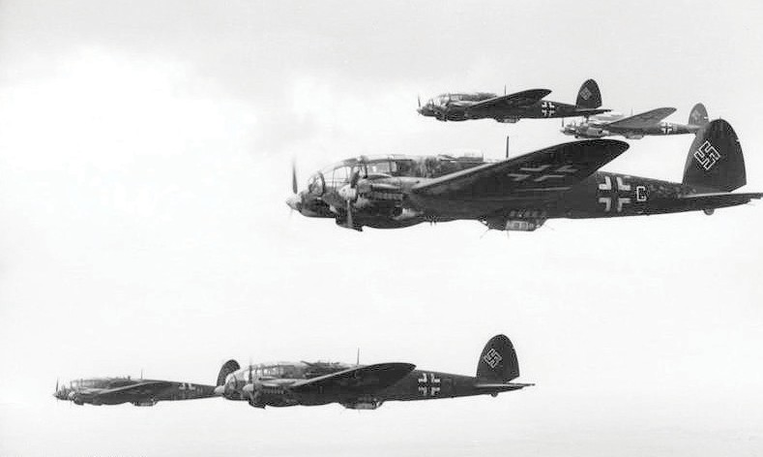
Max. Speed | 470 km/h
Weapons assembled | Machine guns and cannon
Max. bomb-load | Approx. 2,000 kg

Source: Bundesarchiv, Bild 101I-408-0847-10 / Martin
/ CC-BY-SA 3.0

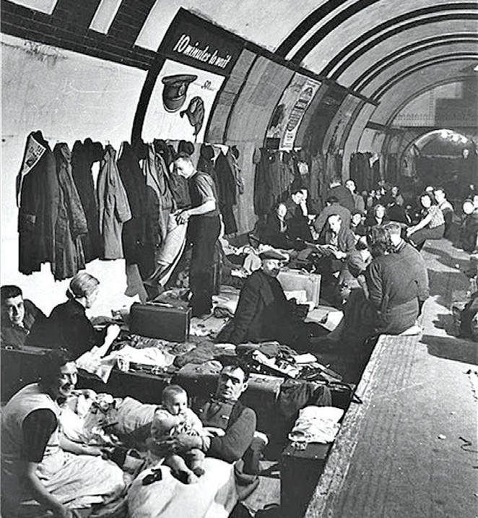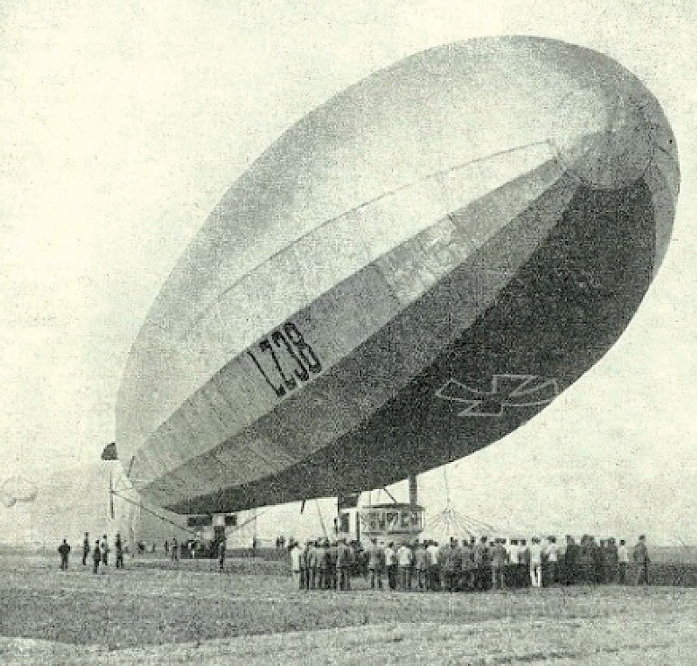

Source: https://www.iwm.org.uk/history/london-in-the-second-world-war

104 Teaching plan 1: Wars and Inventions Teaching plan 1: Wars and Inventions 105

the characteristics of the Zeppelin and the He 111 H bomber.
(a) With reference to Sources C and D, complete the following table by comparing
Source F: The following video is about the devastation caused by the atomic

Category | Zeppelin | He 111 H bomber
Bomb-load | Approx. 2 tons of bombs | Approx. 2,000 kg of bombs
Speed | Max. speed at 137 km/h | Max. speed at 470 km/h
Size | Relatively large | Relatively small

(b) In light of the answers from Question (a), explain why there was greater destruction that brought by bombers.
Though bombers carry a lesser bomb load, their high speed and smaller in size make air defense more difficult, resulting in greater destruction.

Weapons of mass destruction: The emergence of atomic bombs

bombing of Hiroshima.
Video title: Hiroshima: Dropping the Bomb-Hiroshima-BBC
Video URL: https://www.youtube.com/watch?v=3wxWNAM8Cso

- With reference to Sources E and F, describe and explain the destructive power of atomic bombs.
The destructive power of atomic bombs is very great. According to Source E, the bomb can instantly cause tens of thousands casualties, while buildings in the affected areas are ruined. Also, according to Source F, areas that covered by the atomic bombing are large, resulting in greater casualties.

- With reference to Source F, describe and explain the destruction brought by atomic bombs.
Atomic bombs brought massive destructions. According to Source F, the atomic bomb destroyed numerous buildings and leveled the city to the ground. The explosion also caused fire, resulting in more serious casualties.

1. Study Source E and watch the video (Source F), and answer all questions that
follow.
Source E: The following information is about the atomic bombings of Hiroshima and Nagasaki.
Source: UN Photo/Mitsugu Kishida Hiroshima, shortly after a nuclear bomb was dropped on this city in August 1945.
106 Teaching plan 1: Wars and Inventions
Teaching plan 1: Wars and Inventions 107

 | Hiroshima | Nagasaki | 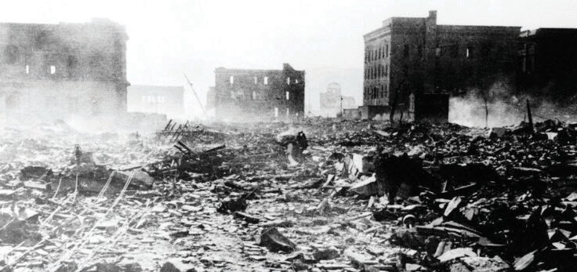
Population before atomic bombing | 255,000 | 195,000
No. of deaths | 66,000 | 39,000
No. of injured | 69,000 | 25,000
Total no. of casualties | 135,000 | 64,000

Based on what have learnt in class, each group compares the changes in armaments and modes of war in the two world wars and completes the table below.
Appendix 4
III. Changes in armaments and modes of war in the two world wars
Post-lesson task

Group:

How did the changes in armaments and the modes of war in the two world wars threaten world peace?

RAFT worksheet for extended activity:

Choose one of the above topics, and write an essay of 150 – 200 words.
When guiding students to complete this worksheet, teachers should emphasise to them that the content of their answers should be aligned with the curriculum aims and learning objectives, including demonstrating positive values and attitude, as well as the importance of cherishing peace etc. in their answers.

Teachers may refer to the following criteria to assess students’ work: Appropriate use of sources; Sufficient content; Effectively present arguments in terms of their role; Correct format; Demonstrate positive values.
108 Teaching plan 1: Wars and Inventions
Teaching plan 1: Wars and Inventions 109
 | World War I (1914-1918) | World War II (1939-1945)
New armaments | (Example of answers) Machine gun  Tank | (Example of answers) Bomber  Atomic bomb
New modes of war | (Example of answers) Trench warfare Mechanised infantry  Increase in number of casualties of soldiers | (Example of answers) Coordinated operations of army, naval and air forces  The casualties of war are no longer confined to the front lines of the war, but spread to all parts of the country

 | Role | Audience | Format | Topic
1 | Survivors of atomic bombing | The United Nations | Complaint letter | The plight of the people of Hiroshima or Nagasaki after atomic bombing
2 | A veteran who served in the US army during the Pacific War | US nationals | Speech | The horrors of war and how to prevent war from happening

Nai Chung Gap at Wan Chai District

Brief introduction of teaching plan:
“Topic 12: The growth and transformation of Hong Kong in the 20th century” in the revised S1-3 History curriculum allows students to study various factors that have contributed to the modernisation of Hong Kong in the 20th century. In the 20th century, Hong Kong experienced industrial development in the inter-war period and the subsequent social changes, and faced the challenges from Japanese invasion and occupation during the Second World War. In response to the changes in the international situation after the Second World War, Hong Kong eventually developed into a modern city today. After studying this topic, students will be able to understand the conditions and changes in Hong Kong before and after the Second World War, including the pre-war industrial development and the rise of local Chinese. The Japanese army invaded Hong Kong at the end of 1941. Although the defenders of Hong Kong resisted resolutely, they could not withstand the Japanese invasion. The topic will introduce the Japanese invasion of Hong Kong and the life under the Japanese occupation. After this brief dark period, Hong Kong was once again back on the track of rapid development. The revised curriculum will study the internal and external factors that contributed to Hong Kong’s post-war development as well as the transformation of Hong Kong after World War II.

This teaching plan shows teachers that combining e-Learning approach and field study enables students to understand the process of Japanese occupation of Hong Kong. The Japanese attacked Hong Kong in December 1941. Despite being far behind the Japanese in terms of number of soldiers and armaments, the defenders in Hong Kong persisted for more than ten days before surrendering and recorded more than 2,000 casualties. To prepare for the field study, teacher first lets students watch online videos to learn about the battle at Wong Nai Chung Gap. Teacher deliberately selects four historical relics (i.e. Ammunition Store and Anti- aircraft gun batteries/Pillboxes/Service Reservoir Lookout/St. John Ambulance Brigade Memorial) to let the students know about the fierce fighting between the two sides. Finally, teacher will give students space to reflect on this history.

Teachers can use this teaching plan to allow students to learn the values of
perseverance, respect for others, and the importance of cherishing peace. The life of Hong Kong people under the iron hoof of the Japanese army is never easy. Despite the shortage of supplies and food, the people of Hong Kong had shown their tenacity and successfully survived the difficult times. This history allows students to understand the importance of perseverance. Teachers can also let students understand the importance of promoting peace through tragedies of war, so as to prevent tragedies from happening again.

To know more (1): Learning history through maps

Teaching plan 2: Field study of the Wong

The following map shows East Asia in March 1941.

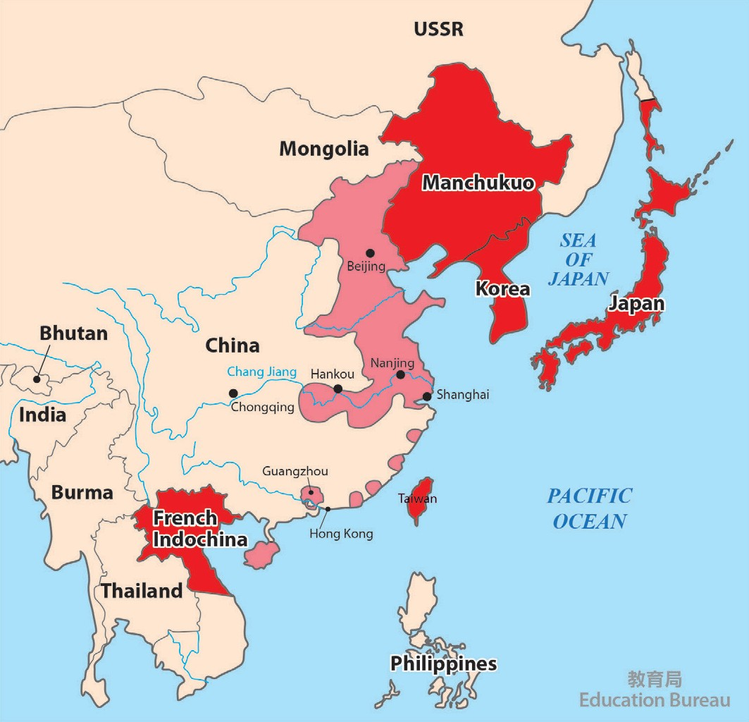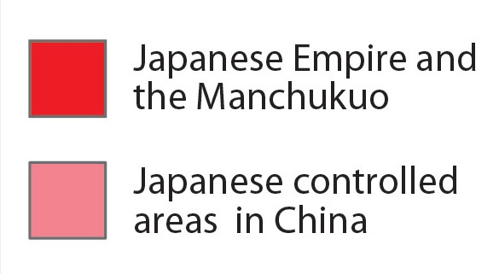 110 Teaching plan 2: Field study of the Wong Nai Chung Gap at Wan Chai District
Teaching plan 2: Field study of the Wong Nai Chung Gap at Wan Chai District
111

The following map shows Hong Kong in 1941 and the routes of Japan’s invasion.

To know more (2): English-Chinese Glossary of terms

Christopher Maltby | 莫德比
Mark Young | 楊慕琦
Wong Nai Chung Gap | 黃泥涌峽
Infantry | 步兵
Pearl Harbor attack | 偷襲珍珠港
Pillboxes | 機槍堡
Lookout | 瞭望點
Geneva War Convention | 日內瓦戰爭公約
Takashi Sakai | 酒井隆
Hong Kong Volunteer Defence Corps | 香港義勇防衛軍（義勇軍）
Trial teaching plan

Field study of the Wong Nai Chung Gap at Wan Chai District

Target students | S3
Topic of trial teaching | Topic 12: The growth and transformation of Hong Kong in the 20th century
 | Field study of the Wong Nai Chung Gap at Wan Chai District
Suggested time | A field study of the Wong Nai Chung Gap (about 3 hours)
Enquiry question | What was the military defence of Hong Kong before the Japanese Occupation?
Learning objectives
Knowledge | - Know the military defence of Hong Kong before the Japanese Occupation
Skills | - Master the historical skills of field study  - Analyse turning point in history
Attitude | - Show respect for those who bravely resisted Japanese aggression in the defence of Hong Kong
Learning and teaching strategy
- Field study
- e-Learning
- Enquiry learning
Learning and teaching materials
Pre-lesson task | - Worksheet for pre-lesson task (Appendix 5)
Field study task | - Map and war situation of Wong Nai Chung Gap (Appendix 6)  - Teacher Guidelines* (Appendix 7)  - e-Learning platform*
Post-lesson task | - Extended activity worksheet (A reflection on field study) (Appendix 8)
* The trial school uses EduVenture as an e-Learning platform. Students log on to the platform and follow the instructions to complete the relevant learning tasks. Other schools can refer to the Teacher Guidelines (Appendix 7) and use appropriate e-Learning platform according to the need of the school.

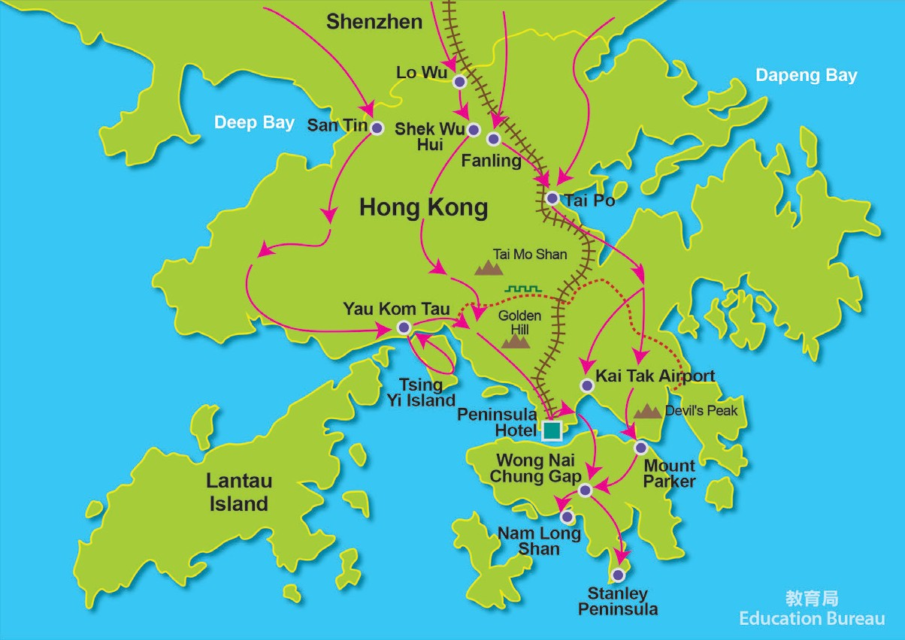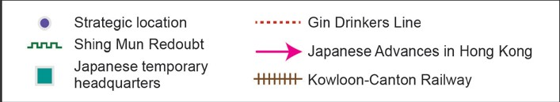
112 Teaching plan 2: Field study of the Wong Nai Chung Gap at Wan Chai District Teaching plan 2: Field study of the Wong Nai Chung Gap at Wan Chai District 113

Field study of the Wong Nai Chung Gap at Wan Chai District
Appendix 5
Trial teaching flow
Pre-lesson task
Flow | Learning and teaching activities | Learning and teaching materials
Pre-lesson task | - Students watch the video “History says Hong Kong”.  - Students complete Worksheet for pre-lesson task. | Appendix 5
Explanation before field study | - Teacher explains the main historical sites and war situation at Wong Nai Chung Gap. | Appendix 6
Field study task | - Teacher leads students to study four historical sites.  - Suggested order of study route: Ammunition Store and Anti-aircraft gun batteries→ Pillboxes→ Service Reservoir Lookout→ St. John Ambulance Brigade Memorial  - Students need to use the e-Learning platform to complete designated learning tasks every time they visit a historical site. | Appendix 7
Post-lesson task | - Students write a reflection on field study and record what they have learnt during the field study. | Appendix 8

What was the military defence of Hong Kong before the Japanese Occupation?

Worksheet for pre-lesson task:
Watch the video “History says Hong Kong”, and then answer all questions that follow.
Video website: https://goo.gl/ufZ9WG (film time 26:00-29:00)

- Why did the Japanese army target Wong Nai Chung Gap?
Wong Nai Chung Gap is located at the centre of Hong Kong Island. The Japanese army called Wong Nai Chung Gap as the “Five Branch Road”, meaning that there were five roads meeting at the gap while connecting different parts of Hong Kong Island, which is of great strategic significance.

- How long did Japan expect to occupy Hong Kong Island? How many days did Japan finally use to occupy it?

The Japanese expected to use about 3 days to occupy Hong Kong Island, but it
took them 7 days to force the defending forces to surrender.

- In the attack of Hong Kong, who was the Japanese commander? General Takashi Sakai

- What made the most headache for the Japanese army in the battlefield of Wong Nai Chung Gap? Explain your answer.
  - Pillboxes: brought a lot of casualties to the Japanese army
  - Hong Kong Voluntary Defence Corps: Even though running out of ammunitions and food, they would not surrender.
114 Teaching plan 2: Field study of the Wong Nai Chung Gap at Wan Chai District
Teaching plan 2: Field study of the Wong Nai Chung Gap at Wan Chai District 115

What was the military defence of Hong Kong before the Japanese Occupation?
Appendix 6
Explanation before field study
War situation at Wong Nai Chung Gap
Map of the Wong Nai Chung Gap Trail

On 8 December 1941, Japan launched the Pacific War and started the invasion of Hong Kong. Due to the limited military strength of Hong Kong, the New Territories and Kowloon were soon occupied by the Japanese army who then focused on the military invasion of Hong Kong Island.

During the night of 18 December, six infantry battalions of the Japanese army landed on the island’s northeast (from North Point to Shau Kei Wan). In the early morning of 19 December, the Japanese army met fierce resistance from the Hong Kong Voluntary Defence Corps on the north side of Jardine’s Lookout. In order to encircle the defending forces in Jardine’s Lookout, the Japanese army changed its course along Sir Cecil’s Ride. Affected by terrain, they directly entered the Wong Nai Chung Gap.

At that time, the island’s defences had been organized into East Brigade and West Brigade while Wong Nai Chung Gap was their brigade boundary. When the defending units discovered the presence of Japanese soldiers at the dawn of 19 December, they opened fire at them from all sides, causing severe casualties to the Japanese.

As the number of the Japanese forces was far exceeded the defenders, the Japanese gradually controlled the two sides of Wong Nai Chung Gap, and effectively blocked defenders’ reinforcement. In addition, the defenders mistakenly underestimated the landing forces of the Japanese army. They put troops into counterattack from all sides on 19/12, 20/12 and 21/12. They were not only unable to shake the Japanese front but also further consumed their defending forces.

The Commander in chief of the army, Major-General Maltby and the Governor of Hong Kong, Sir Mark Young asked for a surrender condition from London on 21 December, but it was rejected by London. The defenders moved to the defensive from 22 December and continued to resist. On 24 December, defenders’ lines of defense were repeatedly broken by the Japanese army and the Japanese began to attack Wan Chai, Aberdeen and Stanley. Although the defenders refused to surrender once again on the morning of the Christmas Day, Maltby realised that the situation faced by the defending forces would soon become untenable under the renewed Japanese attack. In the afternoon, he suggested Sir Mark Young to surrender to the Japanese. The Battle of Hong Kong, which had lasted for 18 days, finally ended in the evening of the same day.

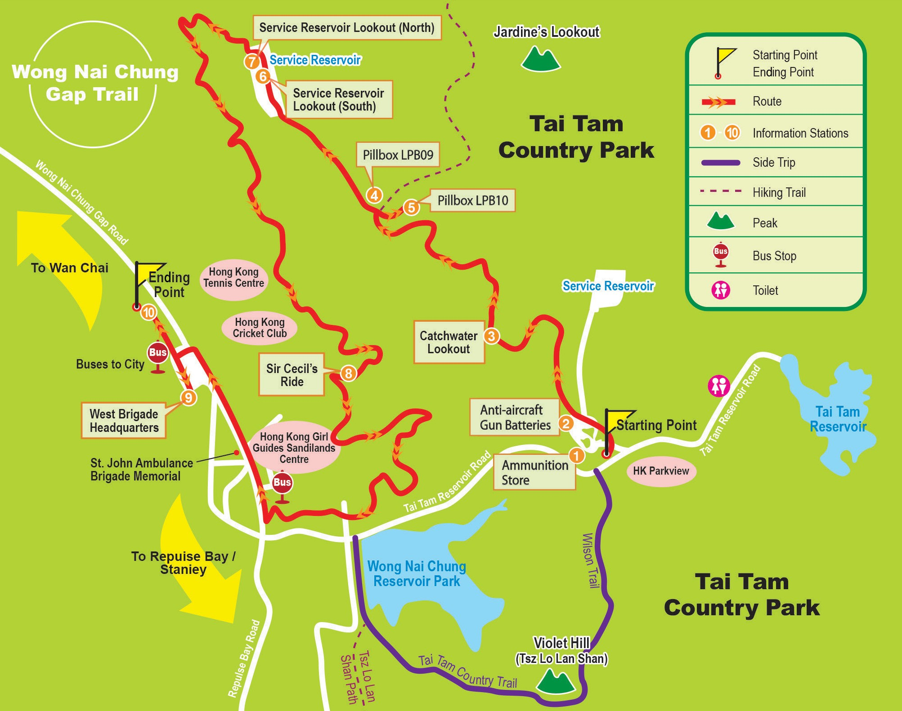 116 Teaching plan 2: Field study of the Wong Nai Chung Gap at Wan Chai District
Teaching plan 2: Field study of the Wong Nai Chung Gap at Wan Chai District
117

What was the military defence of Hong Kong before the Japanese Occupation?

Appendix 7
Teacher guidelines (For reference only)
Field site | Learning and teaching activity  (using e-Learning platform to complete the learning tasks) |  | Learn- ing and teaching materials
 | Student activity:  【Take photos】 Ammunition Store | Find the ammunition store:  - An ammunition store provided ammunition for the above anti-aircraft gun batteries.  - Find the ammunition store and take photo record.
 | Teacher-student interaction:  【Question and answer】 Anti-craft gun  shooting route | Discuss the anti-craft gun shooting route:  - Observe carefully the remains of the anti-aircraft gun batteries. Can you tell in which direction made possible the two air-craft guns shoot down the Japanese warplane?  Please refer to Appendix 6
Pillboxes | Teacher activity:【Brief introduction】 Pillboxes | Introduce briefly the information of the pillboxes:  - The LPB 09 and LPB 10 in Jardine’s Lookout formed a defended locality. The two pillboxes, along with trenches and weapon pits nearby, provided an all-round defence, and the Japanese units spent the whole day to neutralise the position.  - The defenders had stood there firmly for 12 hours until the Japanese soldiers threw the grenades into the pillboxes and made the interior untenable. It was difficult for the defenders to maintain effective resistance.  Please refer to Appendix 6 | Appendix 7
 | Student activity:【Take photos】 Observation Shaft | Find the observation shaft:  - The Japanese army threw the grenades into the pillboxes from the observation shaft, intending to kill the defenders.  - Find the observation shaft and take photo record.

Points to note for students:
- Wong Nai Chung Gap Trail allows public visits. Students should be self- disciplined, speak quietly, do not disturb others and keep the environment quiet.
- Some sections of Wong Nai Chung Gap Trail are difficult and steep. Students must follow teachers’ instruction while observing and pay attention to personal safety.
- If you are having doubts on the way, you should ask your teachers immediately.

Field study and e-Learning activity:
- Teachers lead students to study four historical sites.
- Suggested order of study route: Ammunition Store and Anti-aircraft gun batteries → Pillboxes → Service Reservoir Lookout → St. John Ambulance Brigade Memorial
- Students need to use the e-Learning platform to complete designated learning tasks every time they visit a historical site.

Field site | Learning and teaching activity  (using e-Learning platform to complete the learning tasks) |  | Learn- ing and teaching materials
 |  | Introduce briefly the information of anti-aircraft gun
 |  | batteries:
Ammunition Store and Anti-aircraft gun batteries | Teacher activity:【Brief introduction】 Anti-aircraft gun  batteries | - At the time, two anti-craft guns were placed on the platform to block the enemy planes from attacking the central area. The ruins on the site was originally an ammunition store, and the cannonball pool was located in a safer position down the mountain. | Appendix 7
 |  | - On 19 December, 1941, the fifth air defense battalion,
 |  | which was equipped with two 3.7-inch caliber anti-
 |  | craft guns, had once shot down a Japanese warplane.

118 Teaching plan 2: Field study of the Wong Nai Chung Gap at Wan Chai District Teaching plan 2: Field study of the Wong Nai Chung Gap at Wan Chai District 119

120 Teaching plan 2: Field study of the Wong Nai Chung Gap at Wan Chai District
Teaching plan 2: Field study of the Wong Nai Chung Gap at Wan Chai District 121

Field site | Learning and teaching activity  (using e-Learning platform to complete the learning tasks) |  | Learn- ing and teaching materials
 | Teacher-student interaction:  【Assessment】 Casualties of Japanese army | Assess casualties of Japanese army:  - How many casualties caused by the defenders to the Japanese army through the pillboxes?  Answer for reference: The Japanese army suffered more than 800 casualties, many of which were caused by the pillboxes.
Discuss the reasons for building a lookout:
- Why built a lookout for the pillbox?
 | Teacher-student interaction:  【Question and answer】 Observation  Shaft | Answer for reference: In order to solve the structural defects of the narrow sight of the pillbox, every pillbox in Hong Kong are equipped with a lookout.  Additional information: It was because during the interwar period, the army of every country tended to overestimate the firepower of the machine guns, and believed that the defense zones composing a few pillboxes would be enough to pose obstacles to the enemy.
 |  | Introduce briefly the information of Service Reservoir
 |  | Lookout:
 |  | - The Service Reservoir at Jardine’s Lookout was
Lookout | Teacher activity:【Brief introduction】 Service Reservoir Lookout | opened as early as 1934.  - The Service Reservoir Lookout could observe the terrain of the Wong Nai Chung Gap and help evaluate the operation tactics.  - On one hand, the Japanese army enjoyed a numerical superiority. On the other hand, it controlled the | Appendix 7
 |  | hillside of Jardine’s Lookout overlooking the Wong
 |  | Nai Chung Gap. All these made difficult for the
 |  | defenders to carry out effective counterattacks.

Field site | Learning and teaching activity  (using e-Learning platform to complete the learning tasks) |  | Learn- ing and teaching materials
 | Student activity:  【Take photo】 Offensive route of Japanese army | Find the offensive route of Japanese army:  - The Japanese army marched from the right side (northeast) i.e. North Point and Braemar Hill, and then marched from Sir Cecil’s Ride below Jardine’s Lookout to the rear (southwest) and entered Wong Nai Chung Gap. The Japanese units finally advanced to Mount Nicholson in the front (west), Stubbs Road on the right front (northwest) and Leighton Hill on the right (north).  - Find the offensive route of Japanese army and take photo record.
 |  | Discuss the reasons for Japan’s victory:
 |  | - Why did the Japanese army win the battle at Wong
 | Teacher-student  interaction:  【Question and answer】 Victory of Japanese army | Nai Chung Gap?  Answer for reference: On one hand, the Japanese army enjoyed a quantitative advantage. On the other hand, it controlled the hillside of Jardine’s Lookout overlooking the Wong Nai Chung Gap. All these
 |  | made difficult for the defenders to carry out effective
 |  | counterattacks.
 |  | Introduce briefly the information of St. John
 |  | Ambulance Brigade Memorial:
 |  | - The Japanese army attacked the St. John’s Rescue
St. John Ambulance Brigade Memorial | Teacher  activity:【Brief introduction】 St. John Ambulance Brigade Memorial | Station at the time, causing the deaths of some team members. Two of the team members, who were seriously injured, escaped to the city. They told the military about the attack so the world knew the incident.  - At that time, the St. John Ambulance in Hong Kong | Appendix 7
 |  | was forced to stop operating because it had lost most
 |  | of its team members. It was not until after the war
 |  | that it was reorganised.

What was the military defence of Hong Kong before the Japanese Occupation?
Appendix 8
Post-lesson task
Field site | Learning and teaching activity  (using e-Learning platform to complete the learning tasks) |  | Learn- ing and teaching materials
St. John Ambulance Brigade Memorial | Teacher activity:【Brief introduction】 St. John Ambulance Brigade Memorial | - The St. John Ambulance Brigade Memorial at Wong Nai Chung Gap is thus established. On the second Sunday of November every year, the St. John Ambulance of Hong Kong will hold a mourning ceremony for the memories of the heroic sacrifice of the team members at the time.
 | Teacher-student Interaction:  【Question and answer】 Reasons for St.  John Ambulance being attacked | Discuss why St. John Ambulance was attacked by the Japanese army:  - Why did the Japanese army ignore St. John Ambulance and attack the medical force in violation of the Geneva War Convention?  Answer for reference: The Japanese army might mistakenly recognise the uniform of St. John Ambulance as the British army. At the same time, the Japanese military officers were generally not trained in international law, so they did not know that they needed to abide by the relevant treaties.
 | Teacher-student Interaction:  【Assessment】 Casualties of St. John Ambulance | Assess the casualties of St. John Ambulance:  - How many team members of St. John Ambulance at the time were killed by the Japanese army?  - 35  - 45  - 56  - 66  Answer: C

Extended activity worksheet: A reflection on field study
Using ‘A reflection on field study’ as the topic, write an essay to record the historical knowledge and the historical concepts you have learnt during the field study. The number of words should not be less than 400.

Students can reflect from the following directions:
- Violent nature of war
- Impact on non-combatant military personnel of war
- Strategy and technology level reflected behind the war.

122 Teaching plan 2: Field study of the Wong Nai Chung Gap at Wan Chai District Teaching plan 2: Field study of the Wong Nai Chung Gap at Wan Chai District 123

